Topic: Semaphores – Activity: Roleplay Day: 20.10.2026
For a 6-member team, I recommend a roleplay called “The Printer Problem: Understanding Semaphores in Operating Systems.” It's easy to perform in class, requires almost no props, and demonstrates how semaphores prevent race conditions and manage shared resources.
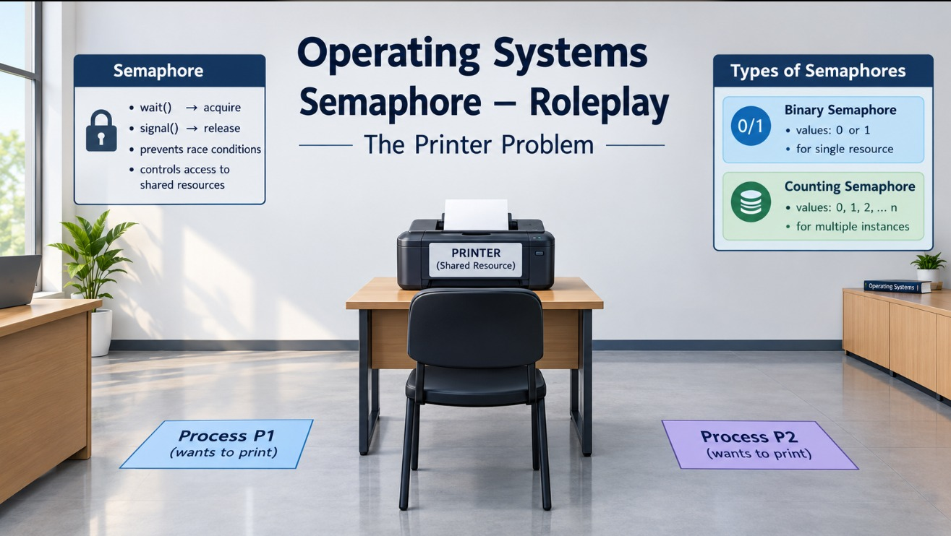

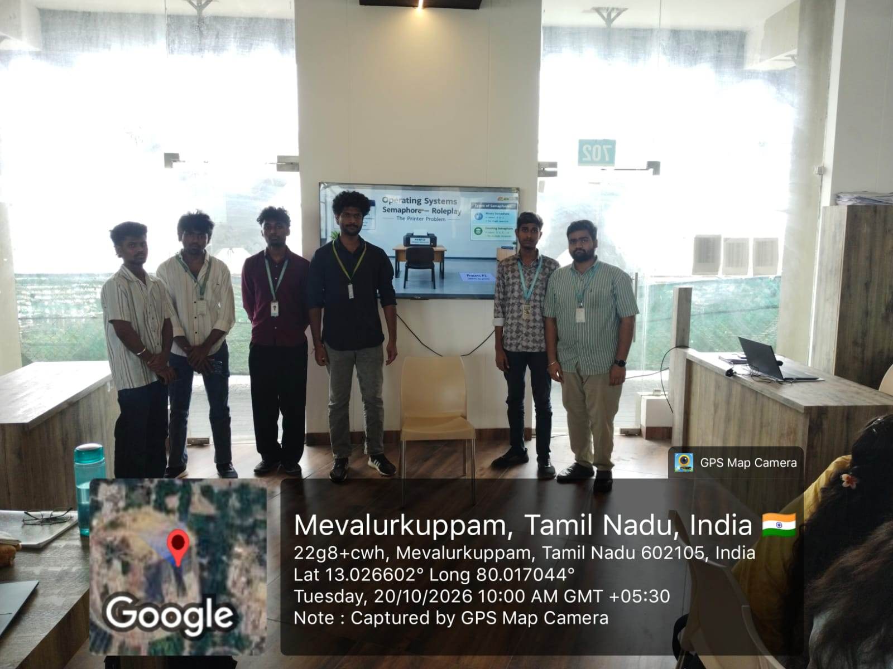

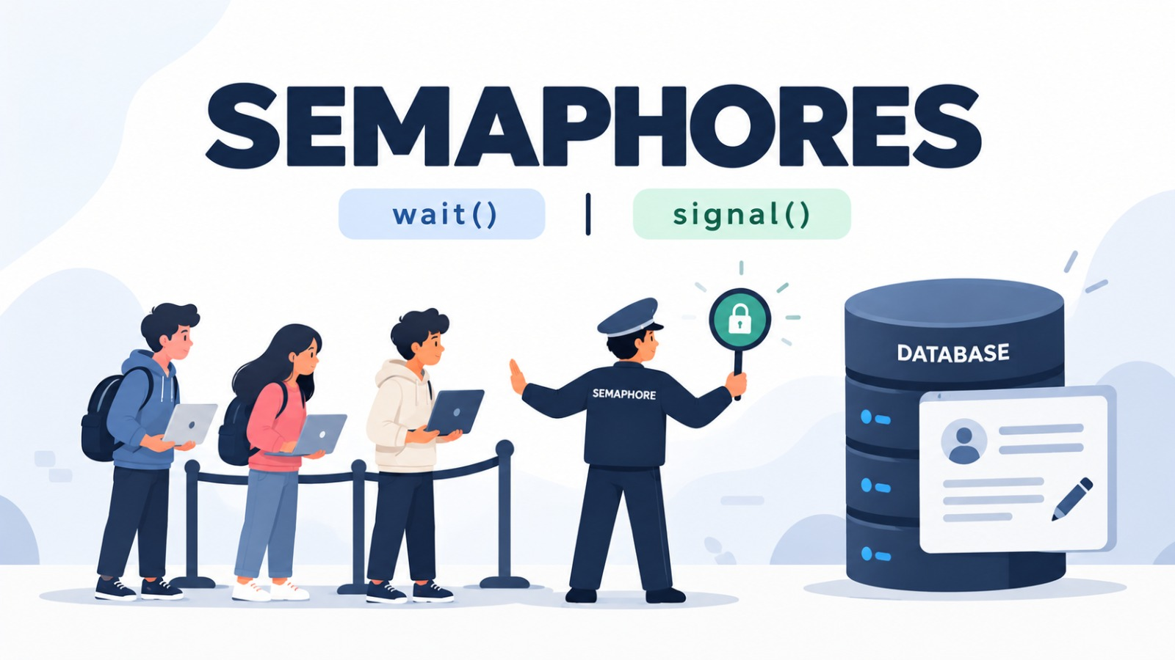

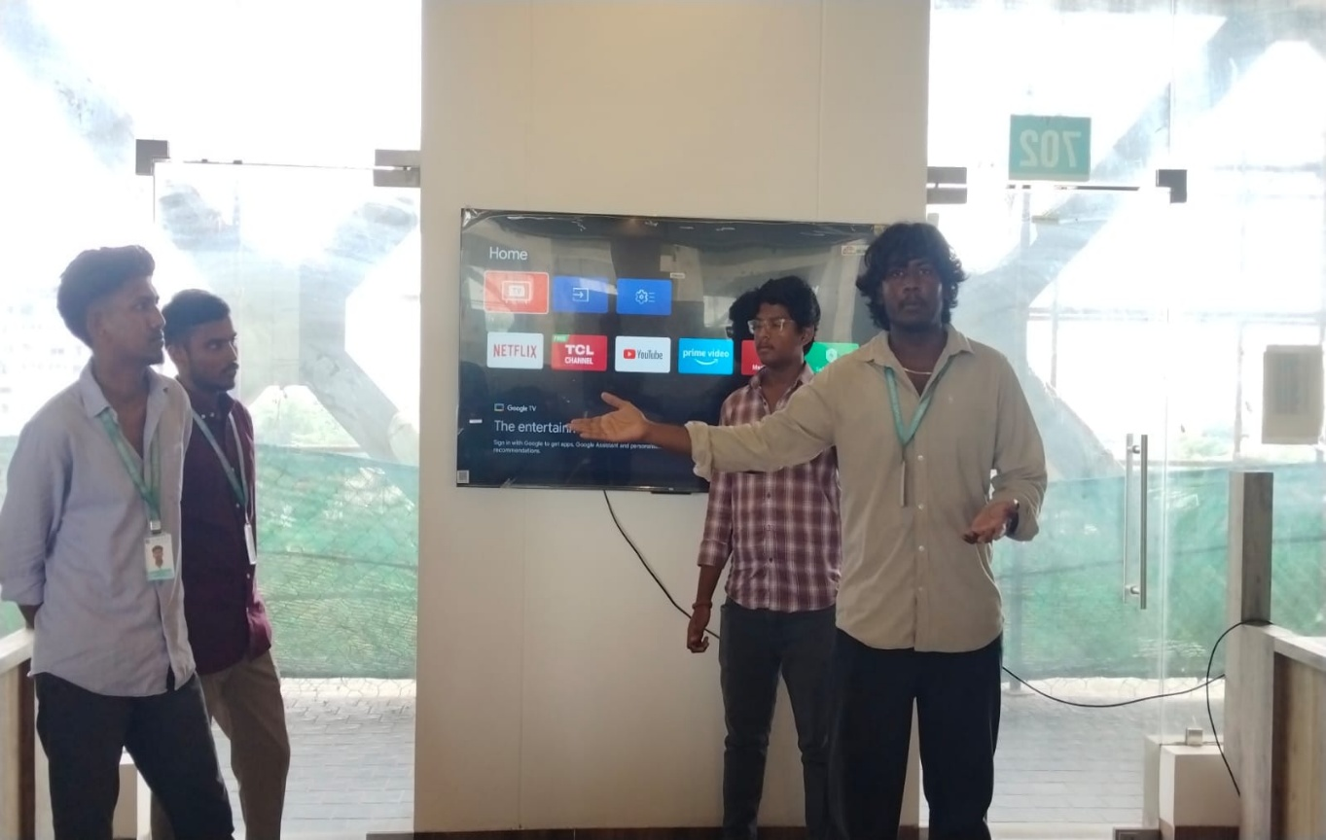

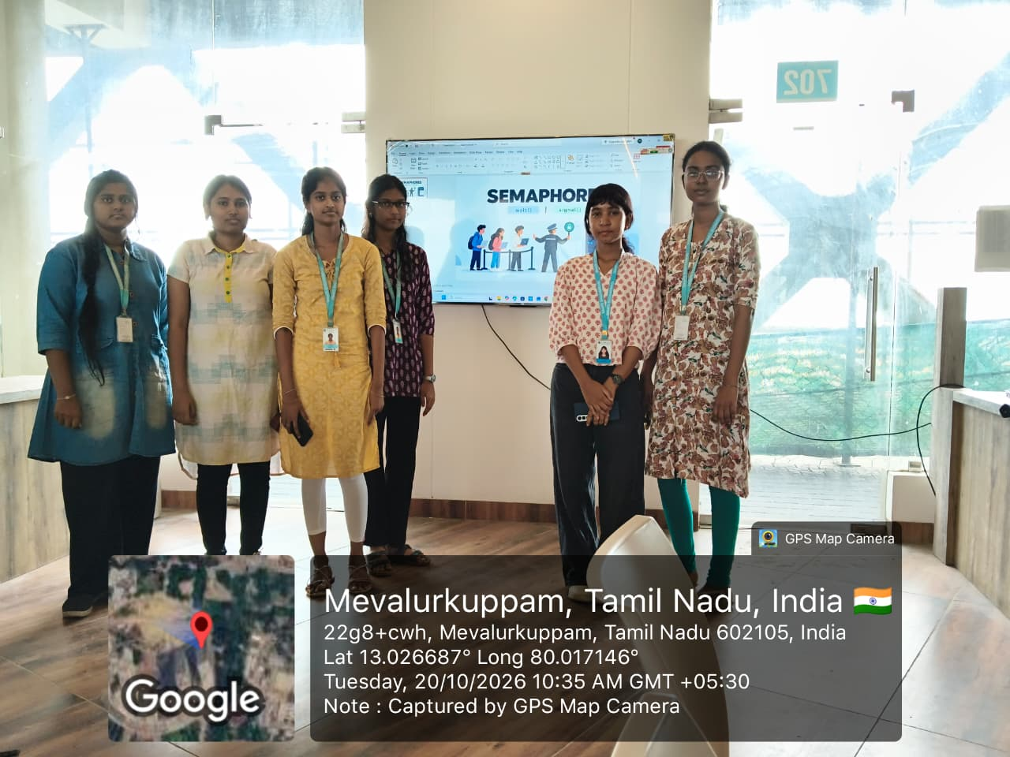

Technical note: In a real operating system, semaphore operations are atomic. With a blocking semaphore, a waiting process is typically awakened when another process signals; the exact internal value bookkeeping can vary by implementation. The roleplay uses a simplified binary-semaphore model.

